Lab 3: Product Evaluation (Sensors 2.0)

EG-UY 1003 Section G2

Kevin Xu

Partner: Tamer Bou Matar, Idriss Dimson

Date of Experiment: Sept 22nd, 2017

Due Date: Sept 28th, 2017

**Abstract**

The objective of this lab was to program a robot built by a EV3 robotics kit. The robot was evaluated for accuracy and precision using both hardcoding and sensors. For the competition, the objective was to run the robot through the provided mini-course in the shortest amount of time possible, and, at the same time, maximize the accuracy and precision. The ranks of the competition were based on the competition ratio, from highest to lowest. The team achieved third place in the competition.

**Introduction**

The concept of product evaluation was introduced in this lab. Product evaluation is a common task for an engineer and for companies. A standard value is used to evaluate a company’s product or a competitor’s design. The goal of the evaluation is to determine an average, and calculate accuracy and precision to test if the product meets the standard. For EG1003 lab, the standard will be 80% precision and accuracy. The product need to meet a tolerance of  1cm for distance and  10 degrees for angle.

Quality improvement is a process of analyzing a design and testing it through physical modeling, computer simulation, or mathematical modeling. Quality improvement is important because it ensures that a product will perform as expected and allows improvement to be made to future works. (NYU, 2017)

Reverse engineering involves reversing a program’s machine code to obtain the original source code or determine the file structures the program uses. Reverse engineering is important when the source code is lost or is not available. (NYU, 2017)

Several concepts and formulas were used during the lab. First is average:

1. 

In equation (1), Ap is the average, P1, P2, P3, …, Pn are the results of the tests, and N is the number of tests performed. The average is compared to the standard (NYU, 2017). The next key concept is accuracy, which refers to the closeness to standard result. Accuracy should always be considered because this is how the results will be verified. Engineers often work on projects that affect people’s safety so it is crucial that the solutions to the problem solved by technical professionals are accurate (NYU, 2017).

1. 

Equation 2 is used to calculate accuracy, the comparison of the average to the standard. In equation 2, Ps is the standard value, and Ap is the value measured (NYU, 2017). Absolute value is used to make sure accuracy is always positive.

(3)

Precision shows the consistency of collected data, or the repeatability of a result. Equation 3 is used to calculate precision, where precision is defined as Prec. Phigh is the highest data value and Plow is the lowest data value. The equation shows how close the results are to each other. Precision, like accuracy, is always a positive number, so absolute value is used in equation 3 as well (NYU, 2017) It is important for engineers to achieve a combination of both accuracy and precision. Percent accuracy is used to judge if a product has passed or failed the standard. The equation for percent accuracy is:

(4)

In Equation 4, %Acc is the percent accuracy, Ps is the standard value, and Ap is the value measured. Adequate precision is determined by an acceptable tolerance, set by the manufacturer. For this lab, the tolerance allowed is 1 cm for distance test and 10 degrees for the angle of deviation test.

Different types of sensors were used in the lab. A sensor is a device that measures a specific value and is used as an input. (NYU, 2017) Different properties can be measured by the EV3 sensors. The three sensors used in this lab are the light sensor, gyro sensor, and ultrasonic sensor. The light sensor can measure the intensity, color, and ambient light. The robot uses light sensor to perform different actions according to different colors. The gyro sensor can measure the degrees it turns or the rate at which it is turning. And the ultrasonic sensor measures the distance between the robot and the closest object to it (NYU, 2017).

For the programming of the robot, switches and loops are used to tell the robot what actions to perform depending on the inputs from its surroundings, measured by the sensors. A switch is an “if-else” statement: if the initial condition is true, the top action will occur, if false, the bottom action will occur. The switch block is used for robots to perform different actions based on the input it gets from the sensors. A switch can only perform the action once, so if repeated action is desired, a loop must be used. A loop can run the code repeatedly until the end statement occurs.

In the competition, only parts provided in the EV3 kits are allowed and no changes can be made to the physical robot design. There is only one shot and no “re-tests.” The trial need to be declared beforehand and cannot be disputed. The competition ratio is used to judge the final results. The team with the highest competition wins.

(5)

Equation 5 is the competition ratio. CR stands for competition ratio and other values come from the Tabulation of Results. The time is how long the robot will take to complete the competition. (NYU, 2017)

**Procedure**

The materials used in the lab include a Mindstorm kit with pre-made robot, a computer with Mindstorms software, a mini-course with accuracy markings, a meter stick and a protractor. Figure 1 below shows the pre-made robot we use in the lab.

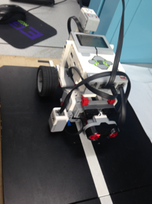

**Figure 1: Pre-made robot**

Before the competition, two sets of code were used to evaluate the robot for accuracy and precision: one is hardcoding without the sensors and the other one is with use of the sensors. The robot was programed to through the first part of a mini-course in a straight line. The goal was for the robot to stop exactly five centimeters away from the wall at the end of the course with minimum angle of deviation.

All the coding was performed in the Mindstorm EV3 software. Part 1 was the hardcoding. A steering block was placed from the Action palette next to the Start block. The port was set to reflect both motors plugged into the brick, which, in this case, was motor B and C. The type of the Steering block was changed to On for Seconds, which would change the Rotations input parameter to Seconds (NYU, 2017). Different values of the Power and Seconds were tested to find the perfect value so that the robot can stop accurately 5cm away from the wall.

In the second part, sensors were incorporated into the code. A blank loop was first inserted into the code and a switch was inserted within the loop. The input of the switch was set to a Light Sensor and the type was set to Reflected Light Intensity. The light intensity of the line was measured using Port View on the EV3 brick. The value of the light intensity was set to the value displayed by the Port View. Two Move Motor blocks were inserted into the top half of the switch. One was set to stop and one to continuously moving. The bottom half was the same as the top only with switched ports. In this way, one wheel would move and one would stay still, making the robot wiggle along the line. The Ultrasonic Sensor was used to measure the distance so that the robot could stop five centimeters away from the first wall. The end statement of the loop was controlled by the Ultrasonic Sensor. The type was set to Distance Centimeters for five centimeters. (NYU, 2017)

Four trials were run with the optimal data input for both hardcoding and sensors (Part 1 and 2). The distance between the robot and wall when the robot stopped and the angle of deviation were recorded for each trial. The angle was recorded as though the straight line is 360 degrees. Then, accuracy, precision, percent accuracy and the pass/fail were calculated and inputted into the Tabulation of Results.

The third and last part was the robot competition. The requirement for the competition was for the robot to travel the second section of the course. The second section consisted of a turning of 90 degrees to the right, advancing forward one tile, another turning of 90 degrees to the right and going up a ramp at the end. The goal of the competition was also for the robot to stop 10 cm away from the second wall at the end of the ramp. Accuracy and precision of both the distance and the angle of deviation were taken into account when evaluating the results of the competition. The rank among the teams was determined by the competition ratio mentioned before.

For the coding of the competition, a Gyro Sensor was used and set to reset in order to set the direction the robot is facing before turning as zero. A Wait block was inserted right after the gyro sensor and the value was set to 2 seconds. A Loop was used to make sure the robot keeps turning until it reached 90 degrees. The end condition of the loop was controlled by the measurement of the Gyro Sensor. A Motor block was inserted into the loop. The motor type was set to Rotations so the robot kept moving until the gyro sensor read 90 degrees. A Steering block was inserted after the loop for robot to travel one tile forward. The first part of the code was repeated for the second turning. The part 2 code was used again for the robot to travel up the ramp using the light sensor and stop 10 cm away from the wall. The time of the competition was recorded by the TA using a stopwatch and data was measured and calculated accordingly for the competition ratio.

**Data/Observations**



**Table 1: Part 1&2 Data**

The data collected for part 1 and part 2 of the lab is shown on Table 1. During all 4 trials in part 1, the value of input of Power was set to -40 and Seconds was set to 3.25. The Power value was negative because robot could only move forwards with negative input. For the second part, the light sensor was set to 50 and the power of the motors were both set to -20 for all 4 trials. The power was limited to -20 because fast speed could make the light sensor not able to respond the reading in time. Figure 2 shows the code used during Part 2.

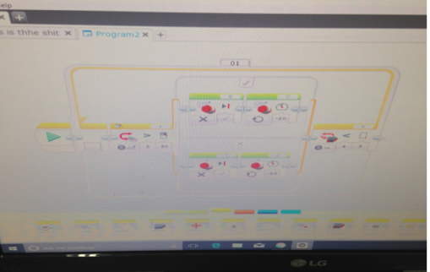

**Figure 2: Part 2 Code**



**Table 2: Tabulation of Results**

Table 2 shows the calculated data of the trials include accuracy, percent accuracy, precision and more. The average results of the four trials were used for the calculations. As it shows on Table 2, Hardcoding is more precise for both distance and angle of deviation, while sensors are more accurate.



**Table 3: Competition Scoresheet**

Table 3 shows the overall results of the competition. The team was ranked 3rd in the competition. The accuracy and precision of the robot was decent while it took too long for the robot to complete the competition. The final competition ratio of the team was 1.8145, with the highest ratio being 2.9215. Figure 3 shows the final code used for the competition.

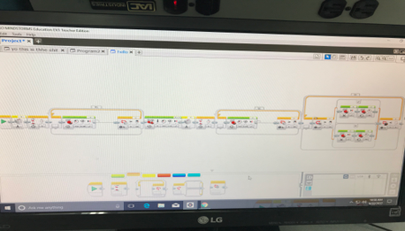

**Figure 3: Final code for competition**

**Discussion/Conclusions**

The lab and competition was overall a success. What worked for the robot was that the coding part was properly handled and appropriate values were inputted into the robot so it could finish the task in the right and optimal way.

There were some experimental difficulties as well. First, the light sensor was not stably attached to the robot, which could generate some mistakes and inaccuracy with the readings. The speed was hard to control when using the sensor and the way to place the robot was also tricky in order to achieve the minimum of angle of deviation.

(5)

Equation 5 is the competition ratio and the final ratio of the team was calculated to be 1.8145. The robot succeeded in the first two parts of the competition ratio, which is the percent accuracy and precision, and failed in the last part, the time consumed.

For future improvements, the sensors should first be placed in the right position and be stable. Also, different strategy can be applied for the competition such as using hardcoding for the robot to go up the ramp. In this way, the time needed can be reduced by a great amount. Finally, finding the right angle and position to place the robot at the beginning of the competition is crucial as well. A perfect angle would make the final results more precise.

**Work Cited**

New York University Tandon School of Engineering. (2017). “Lab 1C: Mousetrap Car.” EG 1003

Online Lab Manual. Accessed 9 September 2017 from manual.eg.poly.edu